|  |  |
| --- | --- |
| **Simple** | **2021** |

**Capabilities covered:**

* Implement Web UI that meets the functional specifications
* Add actions, interactions, business logic using JavaScript
* Develop responsive pages using Bootstrap & JQuery

# 1. Validate User Input Using JavaScript

Refer the web page given below and write JavaScript code to validate the user input as listed below

1. Text boxes should not remain blank
2. Postal code should have exactly six digits, such as 123456
3. Mail id should be validated

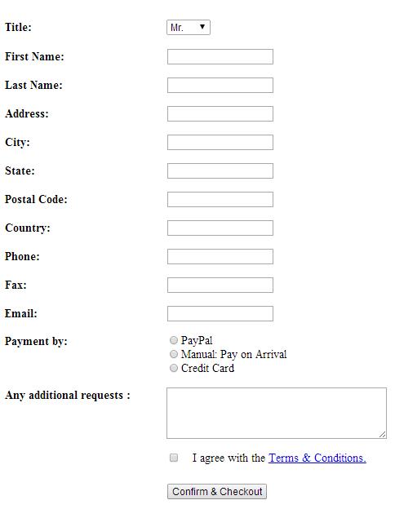

Figure 1: User Details Confirmation and Checkout page

# 2. Handling User Events Using JavaScript

Write JavaScript code to add or subtract or multiply or divide two numbers, entered into two text boxes, as in the web page given below.

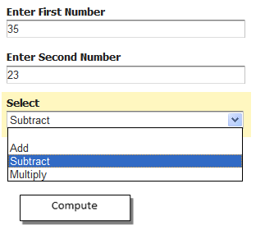

Figure 2: Calculation Page